**BASIC JAVASCRIPT**

**CODE:** 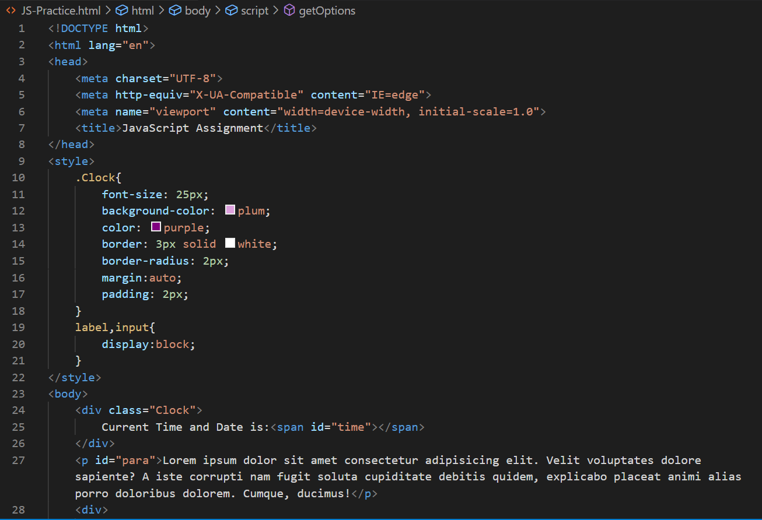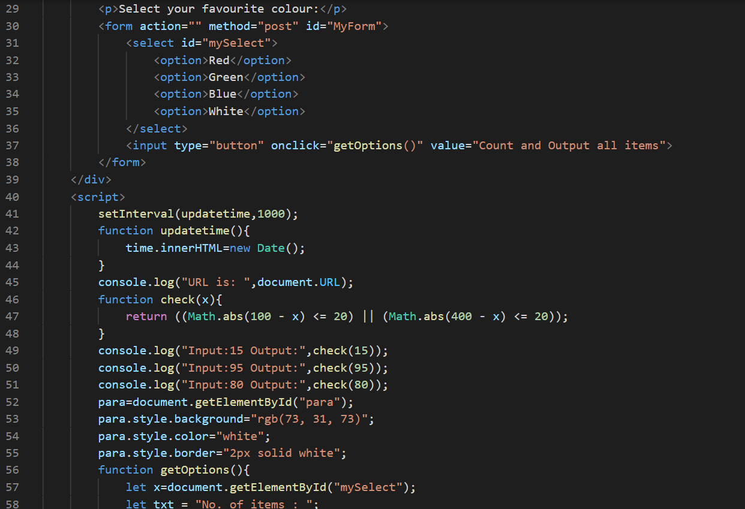

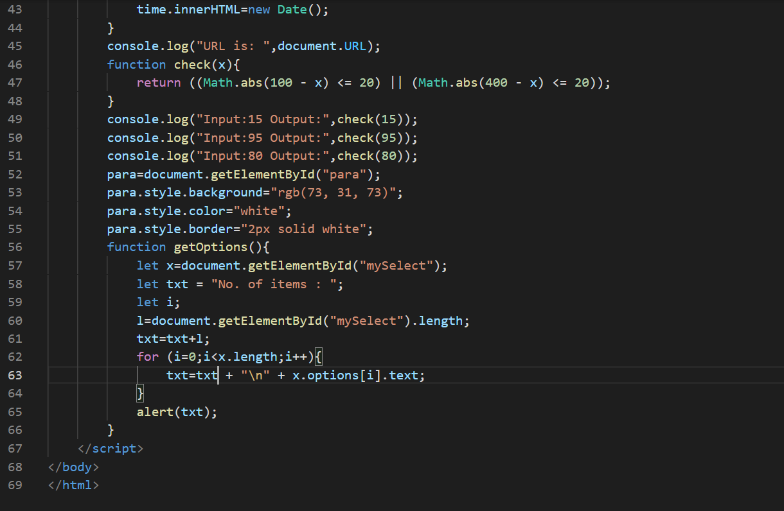 **OUTPUT:** 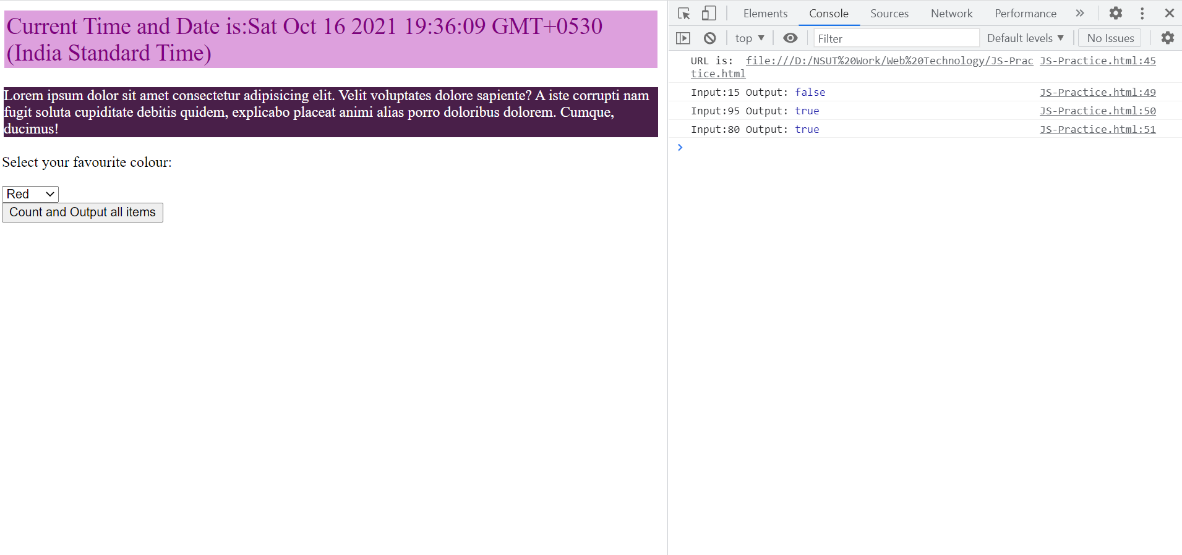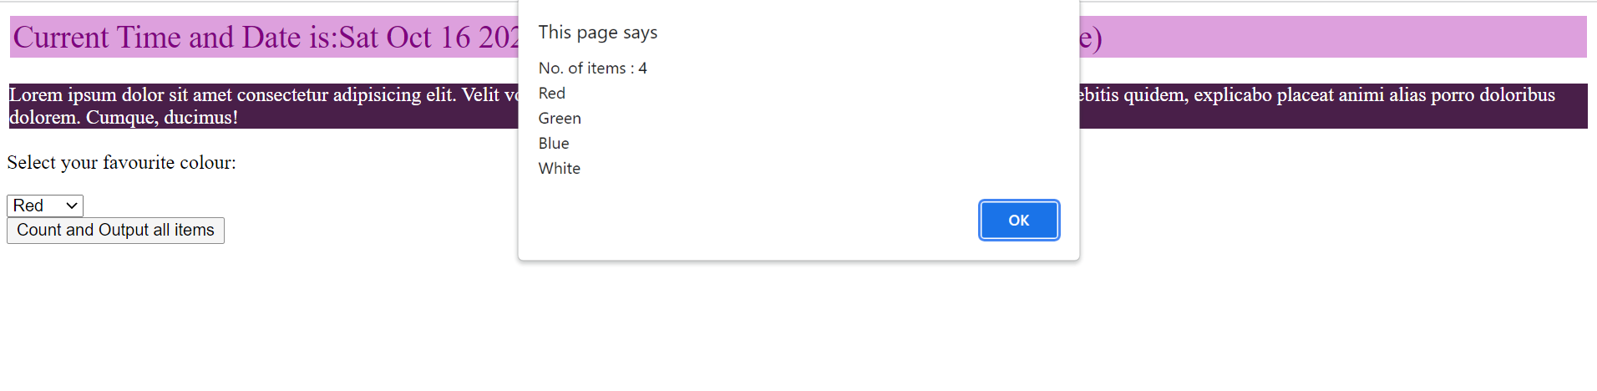

**AMOGH GARG:2020UCO1688  
COE-3**